**Fluid Rigidity: Solid-Body Rotation**

**The Wavetable Project**

Have you ever wondered why Jupiter's rings are so visible? Or why they don’t mix? Or why the gas giant is not a perfect sphere?

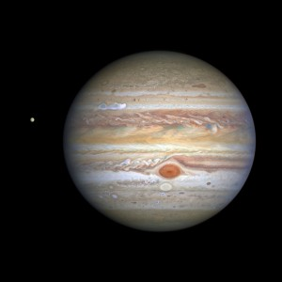

**Figure 1.**  Image of the gas giant, Jupiter. In this image, the planet appears wider than it is tall. [3]

The answer is a phenomenon called solid-body rotation. To start your exploration of fluid dynamics, we will complete two experiments to introduce you to it. Let’s jump into it!

**Before you begin, you will need:**

1. Wavetable
   1. With a RECTANGULAR tank
   2. And a CIRCULAR insert for experiment 2
2. Bottle Cap or any small buoyant object
3. Food dye
4. Camera or iPhone
5. A computer that can connect to the camera. (Secondary Screen)

**Safety:**

1. Keep all exposed wires away from the water tank
2. Keep all long hair tied back and away from any spinning parts of the setup
3. Be careful of the motor—it can get hot, so it is best to avoid touching it too much during the experiments.

## Experiment 1

1. **To begin, fill up your rectangular tank of water halfway, and place it on the wavetable, and turn it on. This should begin the tank’s rotation.**
2. **After the speed of the tank has stabilized for ~1 min, increase the step rate of the motor to** set 2.0. *This notation refers to the code run on the stepper motor. If you are not familiar with it,* [*here*](https://github.com/Exr0nProjects/wavetable_pico#setup) *is the website which explains how to control the speed of the wavetable.*

Did increasing the speed change the properties of the water? If so, how did it change?

|  |
| --- |

This should cause the water to form a parabolic along the side of the tank. Below is an example of what this might look like.

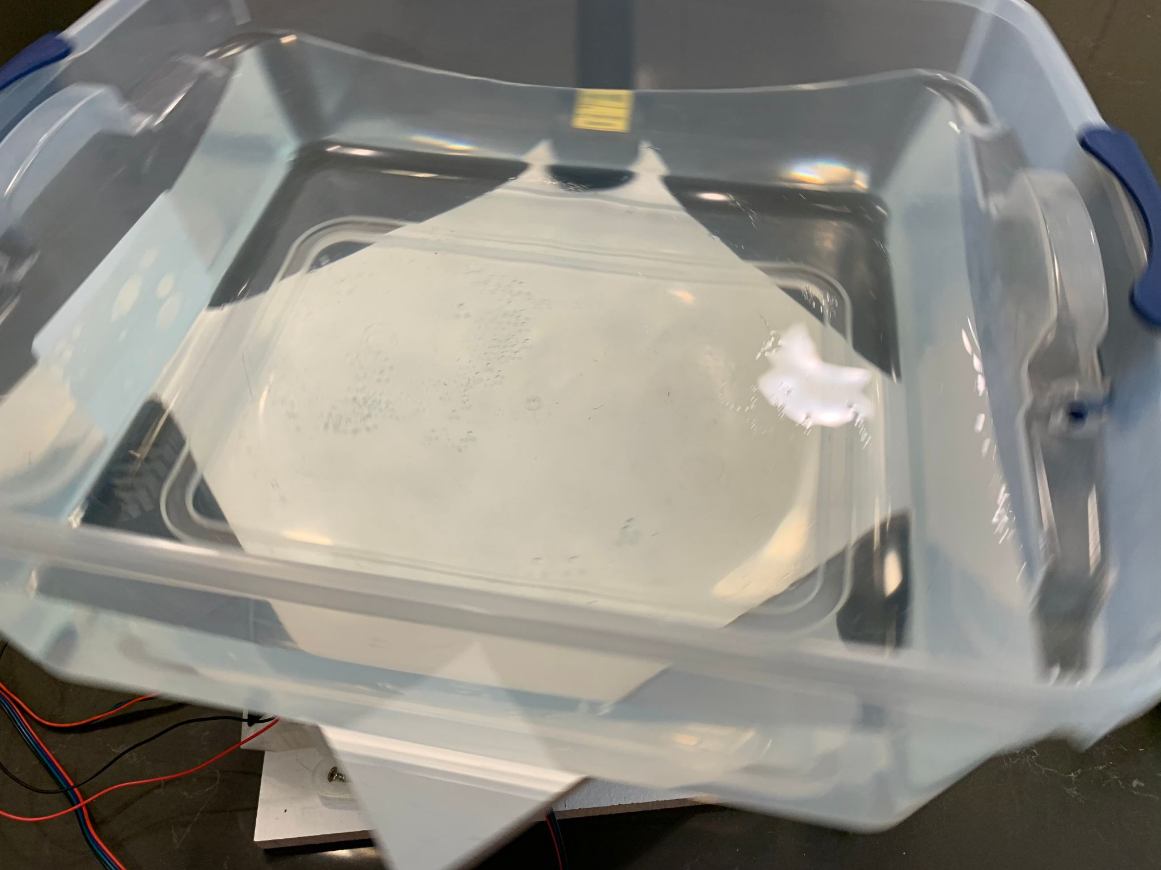

**Figure 2.** Against the walls, the parabolic shape of the water is visible.

1. **After you have recorded your observations, try changing the speed of the tank to see if you can see a trend with how the water behaves. To track your experiment, fill out the table below with the rotation set speed and your observations. We have suggested a few speeds, to begin with.** *Note: any speed above set 3.0 can be dangerous, as the speed can cause the tank to spill water and come off the turntable, potentially damaging the electronic components.*

Record your observations at different speeds:

| **Set speed** | **Observations** |
| --- | --- |
| set 0.5 |  |
| set 1.0 |  |
| set 2.0 |  |
| set ________ |  |
| set ________ |  |

1. **Place a bottle cap near but not at the center of the water. When the bottle cap ceases to move in relation to the water, then solid body rotation has been achieved. The best way to observe if it has been achieved is by watching the tank through the gantry-mounted camera; because it too will be rotating with the tank, when the bottle cap appears stationary on the camera it means it has stopped moving with relation to the tank.** *Note: this can take up to 10 minutes to occur*.

While you are waiting for the bottle cap to stop moving, try to think of reasons why it might be important that the water and the tank are moving at the same speed (angular velocity)

|  |
| --- |

*Please read:*

As the table spins, the movement of the water will slowly catch up with the rotation until the forces balance out and the water stabilizes. This is called solid body rotation; it occurs when the water is stationary relative to the rotating table—ie. when you are watching the water from the gantry-mounted camera, you should see next to no movement.

When the table starts spinning, the water will tend to stay still until a force pushes it along with the rotation. The water closest to the edges will have friction with the walls, which pushes that water along with the rotation of the tank. This moving water in turn forces the water closer to the center to rotate as well until the entire body of water is rotating along with the tank. When this occurs, the water is no longer moving in relation to the tank, and thus a state of solid body rotation is achieved. When this occurs, the surface of the water will take the form of a parabola due to the centrifugal force derived from the rotation—more on this later.

However, the surface of the rotating water is not at the same level as a still tank will be. The water level at the center of the tank is lower than that at the edges, an effect created by "centrifugal force". Centrifugal force is not a true force, but rather a side effect of the rotation of the tank.

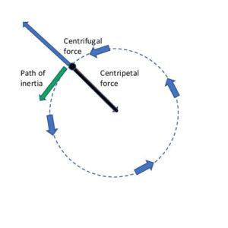

**Figure 3.** Diagram showing the direction of the centrifugal force with relation to a rotating body. [2]

At each instant, each water molecule is moving tangent to the circle of rotation. However, from the point of view of the molecule, the rotating wall gets in the way of this rotation. In this way, the momentum of the molecules continuously pushes them towards the outside of the tank, creating the parabolic surface seen in Figure 2.

1. **Once solid body rotation has been achieved, try dropping a few drops of food dye a few inches in from the corners of the tank.**

How do the drops fall? Are they perpendicular to the floor of the tank, or the surface of the water? How might this be a result of solid-body rotation?

|  |
| --- |

After you have recorded your observations and completed the experiment, turn off the wavetable and empty the tank of water onto some plants.

## Experiment 2

In our second experiment today, we want to highlight some of the properties of a rotating fluid by illustrating them with colored dye. Much of the science behind many of the phenomena you will be seeing today will not be explained in this lab but will be dissected in future labs. The goal of this lab is to tweak your curiosity and start having you think about the forces at play in a wavetable's tank and how they might relate to the real world.

1. **Place a circular insert in the center of the turntable, and fill the tank with water to a depth of approximately 15 cm.** *Alternatively, if you have a circular tank of an adequate/similar diameter and depth, that will work too.*
2. **Turn on the wavetable and increase the rpm until it reaches** set 0.8**. Then, wait for the water to reach the solid body rotation (Hey! That sounds kinda familiar!), and check using a bottle cap.**
3. **Use your hand to stir the water, though try to avoid following a systematic swirl. Pause for 10 seconds. Add food coloring with a pipette, making sure to add the coloring before the currents die away to be able to observe them.** *Note: Overtime convection (change in temperature of the water) occurs and the water in the tank will change per its surroundings. With changing temperatures the patterns created by the dye become even more vibrant and complex!*

Insert, try drawing pictures or describe the patterns you made:

|  |
| --- |

*Please read:*

The key idea in this experiment is the rigidity, or the lack of movement, which a rotating fluid has. This is further fleshed out in the Taylor Columns lab, but for now, we will try to gain a cursory understanding of the phenomena before we dive into the experiment. A rotating fluid (ie. the water in the tank) is constrained to move in the x-y plane when gently stirred. This is what brings out such vibrant patterns because all the different depths of water move at the same rate and in the same direction. This is illustrated in figure 1 below.

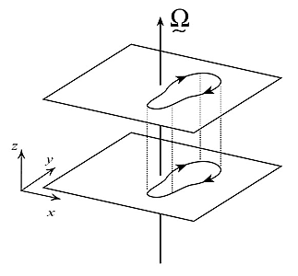

**Figure 4.** Diagram showing how a stirred current’s movement is the same at different depths. [1]

The ‘projection’ of current through the different levels of fluid is a result of it being inviscid and homogenous. Inviscid means that there is little to no friction and homogenous meaning that the fluid has a constant density.

To demonstrate just how rigid a fluid is, we will run another mini-experiment.

1. **Next, repeat the process without rotating the tank and contrast the patterns in the rotating experiment with a non-rotating experiment.**

By gently stirring the water while the tank is spinning, one can induce small currents in the water. By adding drops of food dye at different levels, the rigidity of the fluid becomes apparent. The other experiment will create a stark contrast to this. Without the tank rotating, if we repeat the same steps as before, we will get significantly different results as seen in figures 2-3

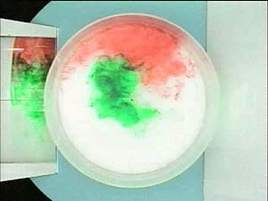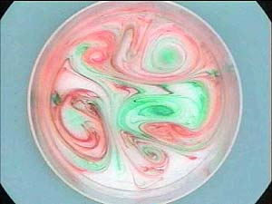

**Figure 5 (left).** The experiment ran WITHOUTthe tank rotating. **Figure 6 (right).** The experiment run while the tank was rotating. [1]

1. **Once you have proven to yourself that there are unique properties inherent to a rotating fluid, try exploring other factors which might change the dye patterns. Try changing the rotation speed before, after, and during the experiment, or change the amount of water used initially. As this is the introductory lab, we encourage you to explore how your wavetable works, and the cool things you can do with it!**

What real-world patterns does the food dye seem to create? Maybe the swirls of clouds on Jupiter? Have fun with it!

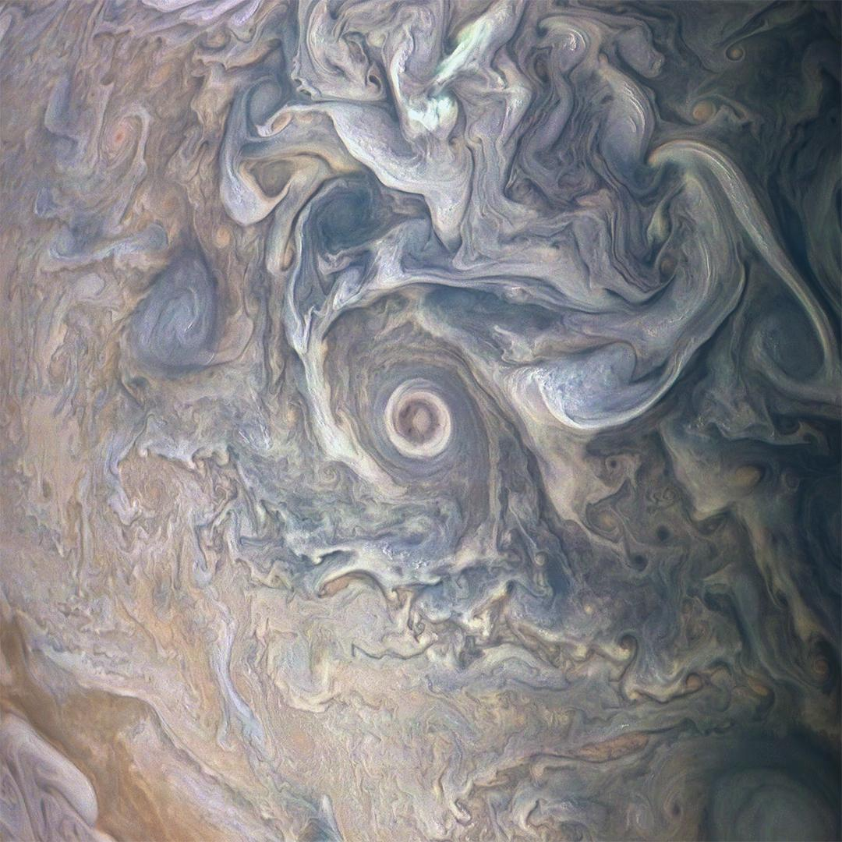

**Figure 7.** Swirling clouds in Jupiter's atmosphere. [4]

This experiment will typically result in vertical columns of dye which will stretch due to horizontal fluid motion into “vertical ‘curtains’” that wrap around the tank. The vertical columns are aligned parallel to the rotation vector (the center of the tank, or the point by which everything is rotating—which is directed upward). This behavior is incredible to visualize and far different from normal fluids—and will be further explained in the Taylor columns lab.

Record your observations below!

| **Set speed** | **Observations** |
| --- | --- |
| set 0.5 |  |
| set 1.0 |  |
| set 2.0 |  |
| set _______ |  |
| *General Observations:* |  |

**Glossary**

* Convection
  + “The movement caused within a fluid by the tendency of hotter and therefore less dense material to rise, and colder, denser material to sink under the influence of gravity, which consequently results in the transfer of heat.”
* Rossby Number
  + A unitless number describing the type of flow of a fluid. A small Rossby number means that the flow is geostrophic and is primarily affected by the Coriolis force and relative spin of the fluid (ie. in the ocean). A large Rossby number means that the spin of the planet is insignificant and can be neglected (ie. in tornados) because in that scenario the inertial forces are much more powerful.

**Examples**

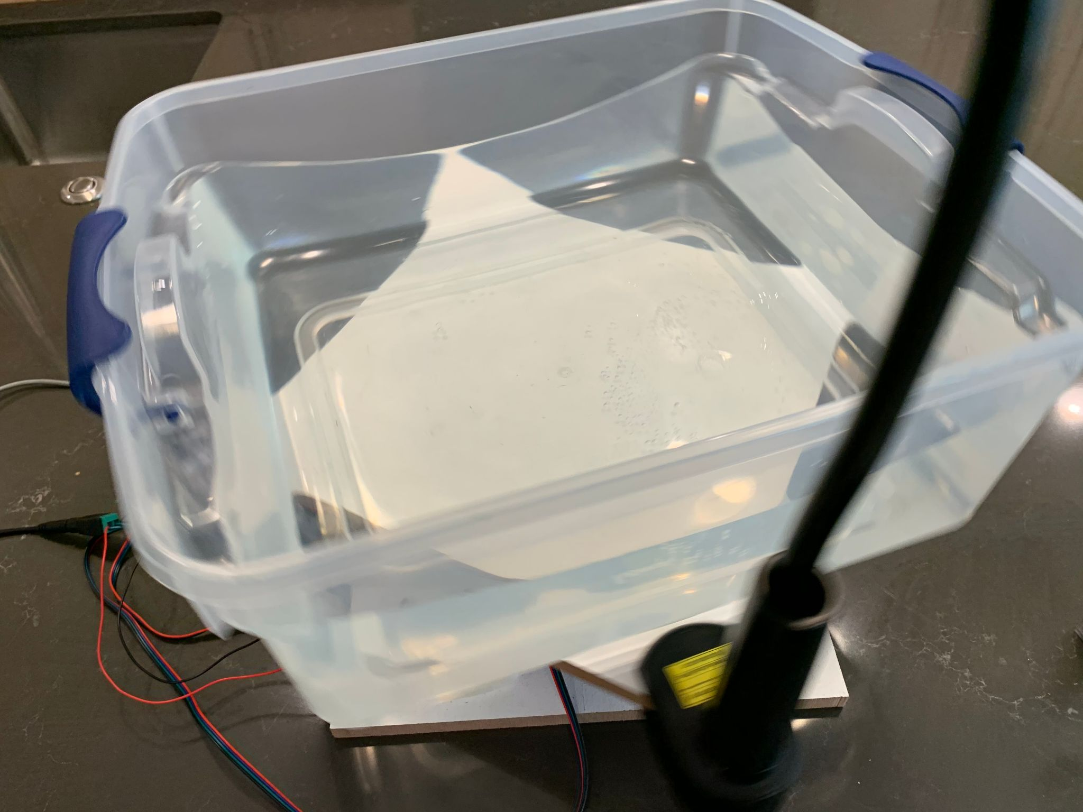

**Figure 8.** The parabolic shape of the water during the first experiment.

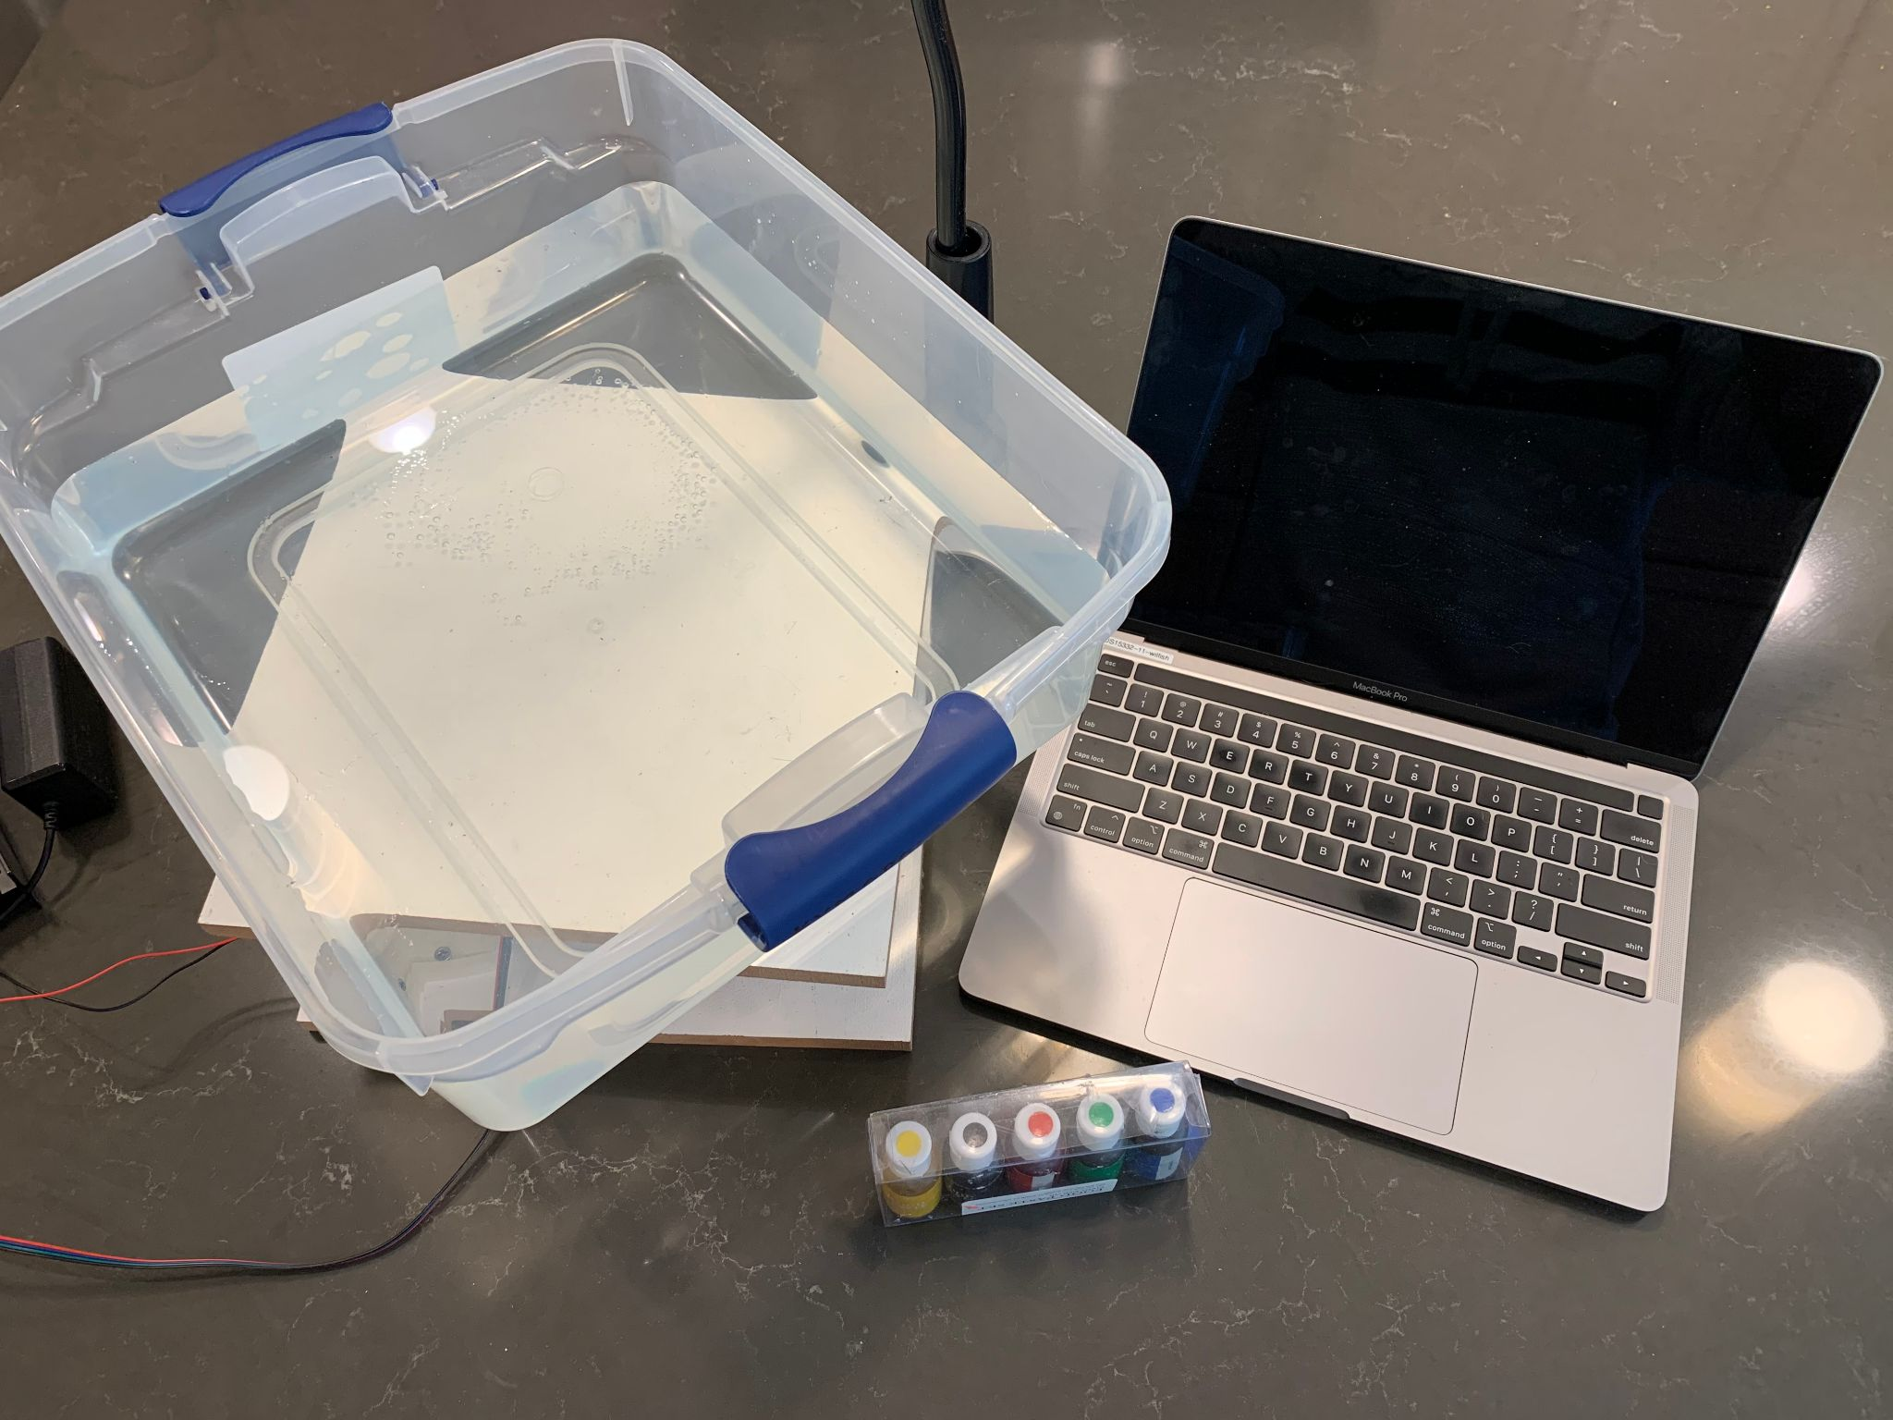

**Figure 9.** Materials needed.

**References**

1. MIT. “Taylor Columns: Introduction.” *Weather in a Tank*, weathertank.mit.edu/links/projects/taylor-columns-introduction.
2. https://www.dreamup.org/centrifugal-force/centrifugal-force-diagram/
3. https://www.newscenter1.tv/jupiters-monster-storm-not-just-wide-but-surprisingly-deep/
4. https://www.nasa.gov/image-feature/jpl/jupiter-s-swirling-cloudscape